📄 Portfolio Entry: Automated Cryptocurrency Volatility Monitor
Role: Integration Developer | Tech Stack: SAP Integration Suite (CPI), Groovy, REST, SMTP
💼 Executive Summary
In high-volatility markets, manual monitoring is inefficient and prone to human latency. I designed and deployed an Event-Driven Alerting System that autonomously monitors cryptocurrency assets 24/7.
The solution utilizes an Exception-Based Reporting model: instead of spamming the user with hourly updates, the system analyzes market data in real-time and remains silent unless specific critical thresholds are breached (e.g., a price crash). This reduces "alert fatigue" while ensuring immediate awareness during critical events.
🏗️ Technical Architecture (The "Fetch-Analyze-Act" Pattern)
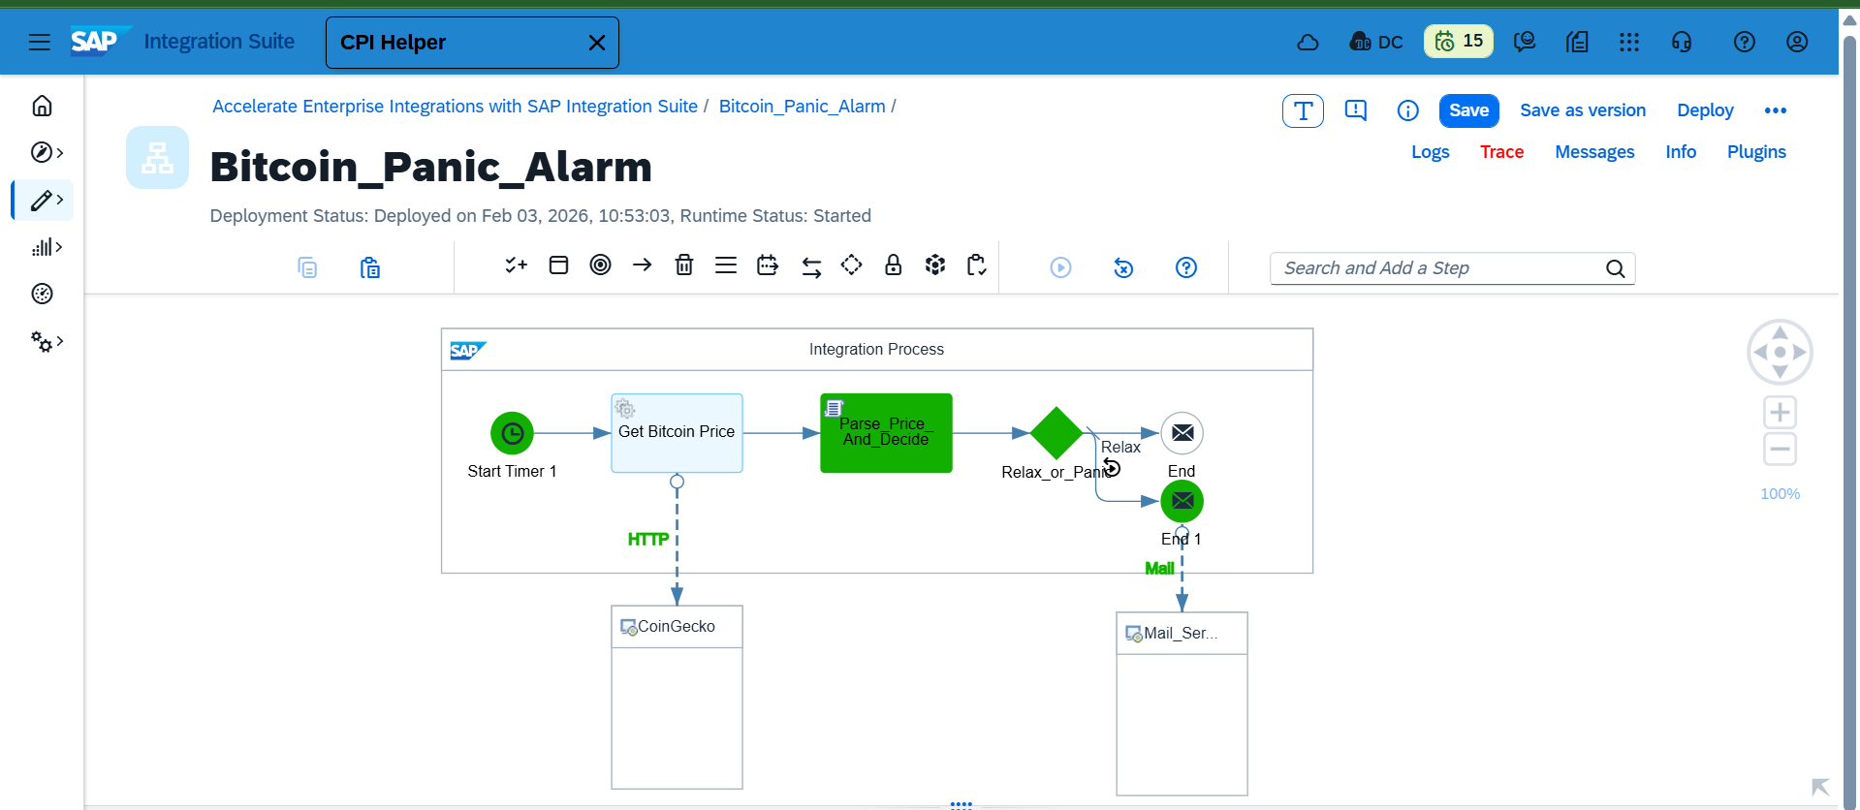
The integration flow follows a strict three-stage pipeline to ensure separation of concerns:
- Ingestion Layer (Fetch):
  - Trigger: Scheduled Timer Event (Hourly).
  - Protocol: HTTPS/REST (GET).
  - Source: CoinGecko API. Architectural Note: Originally provisioned for CoinDesk, but migrated to CoinGecko during the testing phase to resolve persistent DNS/Availability issues, demonstrating system flexibility.
- Logic Layer (Analyze):
  - Data Parsing: Utilized Groovy Scripting with JsonSlurper to ingest raw JSON payloads.
  - Type Safety: Implemented explicit type casting (toInteger()) to prevent common string-comparison errors in the routing engine.
  - Decision Engine: A boolean flag (isPanic) is calculated within the script, isolating the complex logic from the routing step.
- Notification Layer (Act):
  - Router: Diverts traffic based on the isPanic property.
  - Channel: SMTP Adapter (Gmail) with TLS encryption.
  - Output: Dynamic email injection (e.g., "Bitcoin CRASHED to [Price]") providing immediate context in the subject line.
🔧 Key Challenges & Solutions
Challenge | Root Cause | Solution Implemented
Logic Failure | The Router step interprets < symbols as XML tags, breaking mathematical comparisons. | Encapsulation: Moved the logic into a Groovy Script, determining True/False status before the router.
Type Casting Error | toInteger failed as a property reference. | Debug & Fix: Identified missing method syntax; corrected to .toInteger() to ensure proper object method execution.
API Reliability | Primary provider (CoinDesk) returned frequent connection timeouts. | Failover: Rapidly reconfigured the HTTPS adapter to utilize a secondary provider (CoinGecko).

🔧 Technical Deep Dive: Troubleshooting & Resilience
Challenge | Technical Detail (The "Stack Trace") | Resolution
Groovy Syntax Error | groovy.lang.MissingPropertyException: No such property: toInteger | Root Cause Analysis: The script attempted to access .toInteger as a property (variable) rather than invoking the method.  The Fix: Corrected syntax to .toInteger() to explicitly call the casting method.
Implicit Typing | class: java.lang.Integer | Insight: The JsonSlurper parser automatically inferred the data type as Integer from the source, causing a conflict when the code treated it as a String requiring conversion. Added explicit type checking logic.
Logic Routing | XML Parser vs. Math Operators | Architectural Decision: Bypassed the Router's XML-centric limitations (which misinterpreted < as a tag) by encapsulating the boolean logic (isPanic = true) inside the Groovy script.

💻 Code Highlight: The "Decision Engine"
This Groovy script serves as the brain of the integration, parsing the complex JSON structure and enforcing type safety.
Groovy
import com.sap.gateway.ip.core.customdev.util.Message
import groovy.json.JsonSlurper

def Message processData(Message message) {
// 1. Ingest & Parse
def body = message.getBody(String.class)
def jsonParser = new JsonSlurper()
def response = jsonParser.parseText(body)

// 2. Extract & Cast (The Fix)
// Explicitly casting to Integer to ensure mathematical accuracy
def currentPrice = response.bitcoin.usd.toInteger()

// 3. Business Logic
// Set 'Panic Mode' only if price drops below threshold
if (currentPrice < 100000) {
message.setProperty("isPanic", "true")
} else {
message.setProperty("isPanic", "false")
}

return message
}
📸 Visual Verification
- Success State: The system correctly identified a price of $78,786, triggered the "Panic" route, and delivered the alert instantly.
- Evidence: (Email receipt with dynamic price injection).
- 